Theme template: different generations in the workplace

This month at LifeCheck is all about mental resilience. We are joining the Mental Health Awareness Week, which this year focuses on the theme Bridging: understanding one another and doing what’s needed together to become more mentally resilient. At work, we often collaborate with colleagues from different generations, who may each have their own way of communicating, learning, and working. These differences can actually make teamwork more creative, innovative, and effective. Research shows that employees generally experience cross-generational collaboration as positive. Teams that include a mix of ages and backgrounds perform better, learn faster, and enjoy their work more.

Fun facts about generations in the workplace
- Gen Z (1997–2012): Grew up with smartphones, switches quickly, and values clear communication and direct feedback. Mental health and openness are important to them, and they like to make an impact even in smaller projects.
- Millennials (1981–1996): The bridge builders between younger and older colleagues. They value flexibility, growth, and transparency, enjoy collaborating, and learn best by doing.
- Generation X (1965–1980): Practical, independent, and solution-oriented. They appreciate clarity and trust, and are often seen as informal mentors in the workplace.
- Baby Boomers (1946–1964): Have a wealth of experience and are happy to share their knowledge. They have a strong work ethic and a good understanding of how workplace cultures have evolved over the years.

Tips to strengthen cross-generational connection
- Shadow a colleague from a different generation
By observing someone else’s approach, you gain insight into different ways of working and may discover practical tricks that you can use yourself.
- Ask why someone does something a certain way
Generations grew up with different work habits. One person prefers email, another sends a quick chat message. By asking what works best for them, you create understanding and find a way of working that suits you both.
- Share what you prefer in communication
Some colleagues want clear steps, others like short and direct messages. Expressing your preferences helps prevent misunderstandings, which often stem from generational differences.
- Share a work hack from your generation
Maybe you know exactly how to use a digital tool more efficiently or how to stay organised during busy periods. Sharing tips helps combine the strengths of different generations.
- Focus on similarities, not just differences
Even if your working styles differ, in the end all generations want the same things: good teamwork, feeling heard, and achieving strong results together. Naming this helps create more connection naturally.

Try applying some of these tips. If you feel you could use more support with collaboration, communication, or stress, simply schedule a consult with a coach via the LifeCheck platform.

Not signed up for LifeCheck yet?
- Visit https://startjouw.lifecheck.nl/ or download the LifeCheck app using the QR codes.
- Create your account using a one-time activation code: EMPLOYERNAME-yourstaffnumber (for example, ROBIDUS-012345). Tip: You can find your staff number on your payslip.
- That’s it! You’re ready to start exploring consultations, coaching, and lifestyle programs right away.

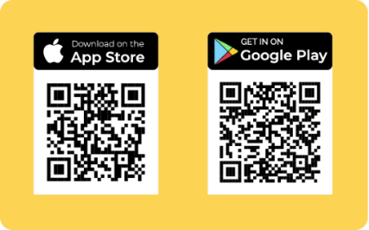
Check out these videos to see how to register via the app or via the website

